NVDA current position:

Is *not* increasing supply to meet excess demand for the cards, worry is that if the bubble bursts then they will be sitting on a bunch of inventory etc.

This buying frenzy will hurt in the future because once the market crashes miners will flood the market with cards. Making it harder to sell.

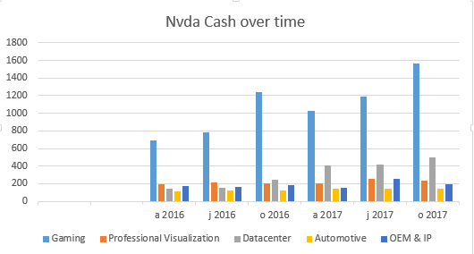

Prediction:  
 - Nvidia will try and sit on next gen cards until the bubble bursts so that the cards flying into the market are less desirable than the ones NVDA is providing.

* 60% of revenue is from gaming segments, the rest is from other sources. Datacenter is growing steadily.

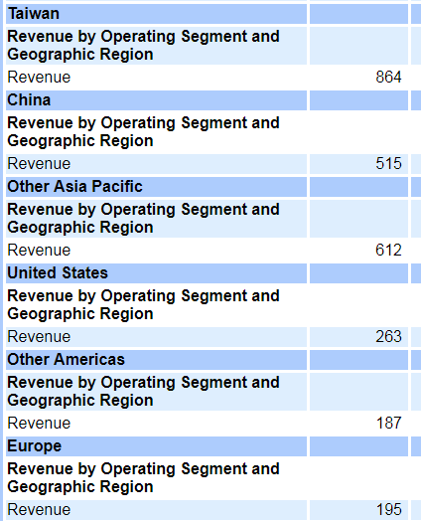

Most of the money comes from Tiwan and China, so in that case if news comes out that it’s banned in either of those: and Nvidia has already launched cards there, short Nvidia.

Bubble bursts:

-Regulation.

-People stop putting money into crypto currency (Bubble bursts, with no next chump to buy for more cash everything crashes)

Other big companies adopt the technology and leave the chain behind.